**Sassafras Systems – Remote Labs**

Visit [**https://stats.labs.csus.edu/ECS/maps**](https://stats.labs.csus.edu/ECS/maps) to access available ECS lab systems remotely. You must be on the [**CSUS VPN using the GlobalProtect VPN Client**](https://www.csus.edu/college/engineering-computer-science/computing-services/remote-tools.html#connecting-to-the-csus-vpn-via-the-global-protect-vpn-client) to access this site.

Only ECS students or those students enrolled in ECS classes will have access. In addition to [**Hydra**](https://www.csus.edu/college/engineering-computer-science/computing-services/remote-tools.html#what-is-hydra-how-do-i-work-with-engineering-software-from-home), which is still accessible to students with existing ECS accounts, we hope this new system drastically increases software performance and convenience for every ECS student.

**How to Connect**

1. Log onto the [**CSUS VPN.**](https://www.csus.edu/college/engineering-computer-science/computing-services/remote-tools.html#connecting-to-the-csus-vpn-via-the-global-protect-vpn-client)
2. Visit [**https://stats.labs.csus.edu**](https://stats.labs.csus.edu/) and navigate to the lab and system you wish. ECS systems are under the ECS tab in "Maps".
3. Click the "Connect" button, which will download a Microsoft Remote Desktop session.
4. There may be additional security prompts, please read and then allow the session to continue.
5. When the login window opens, select "More Choices" and then "Use a Different Account". This is necessary because by default the credential window may be trying to use your personal system's login rather than your CSUS credentials, depending on your local system.
6. Enter your CSUS username in the following format: **CSUS\your username**. Enter your CSUS password.

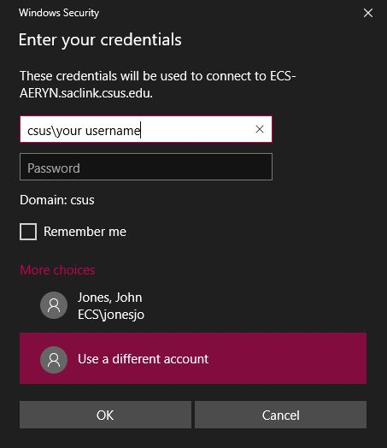Login Credential Window. Enter your CSUS username and password.